1. Launch request, custom intent handlers. Also added the Alexa skill trigger

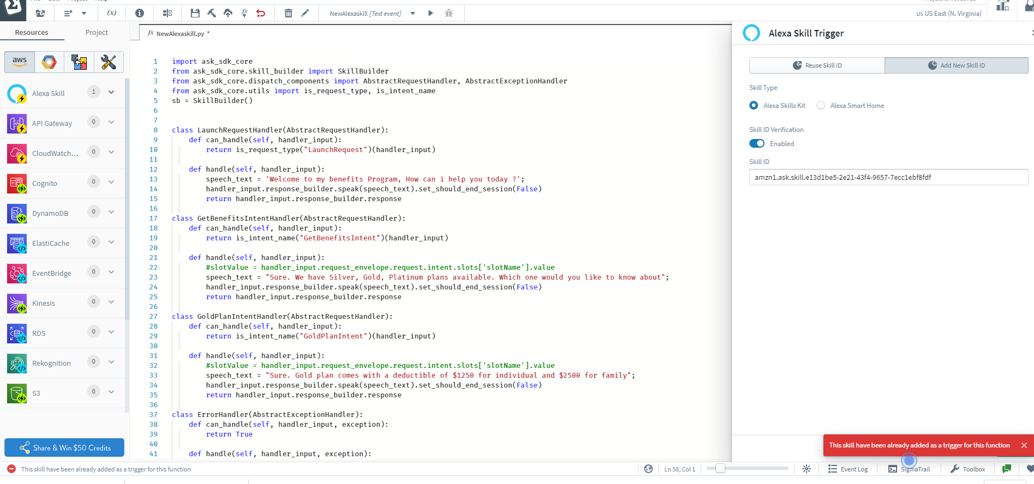

1. Project Deployed

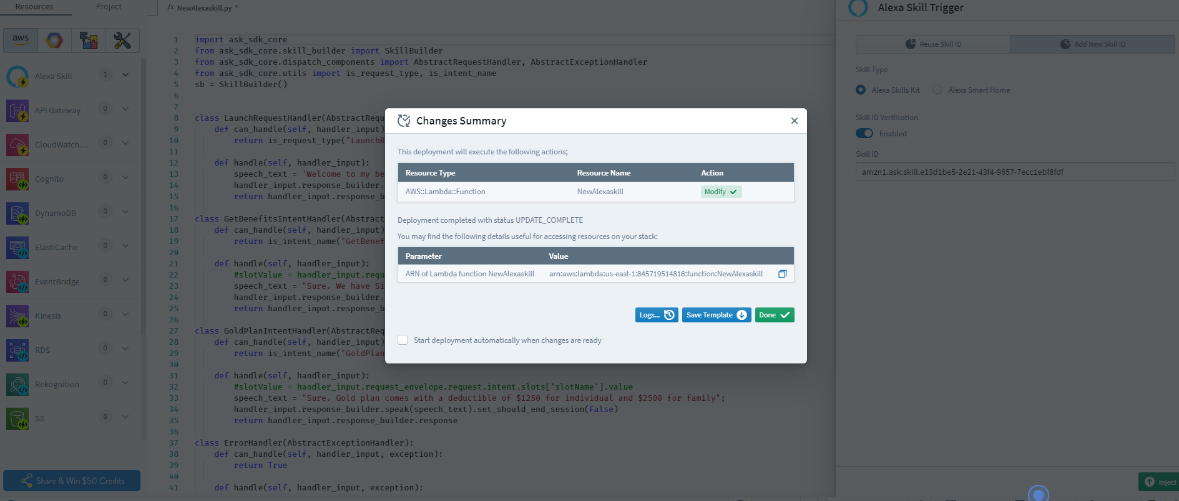

1. Updated the end point with lambda ARN (sigma editor)

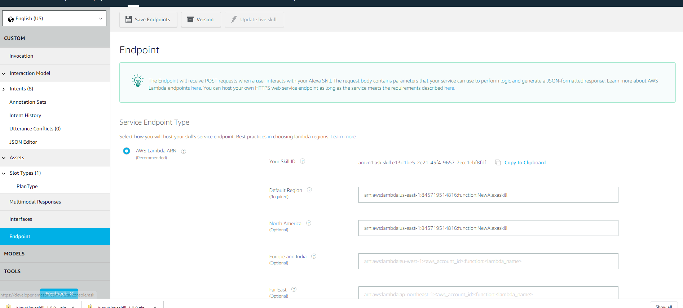

1. Alexa invocation

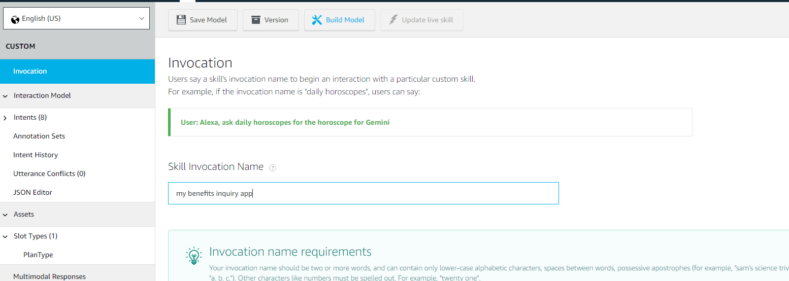

1. Customs in console. Same as what I added in Sigma editor

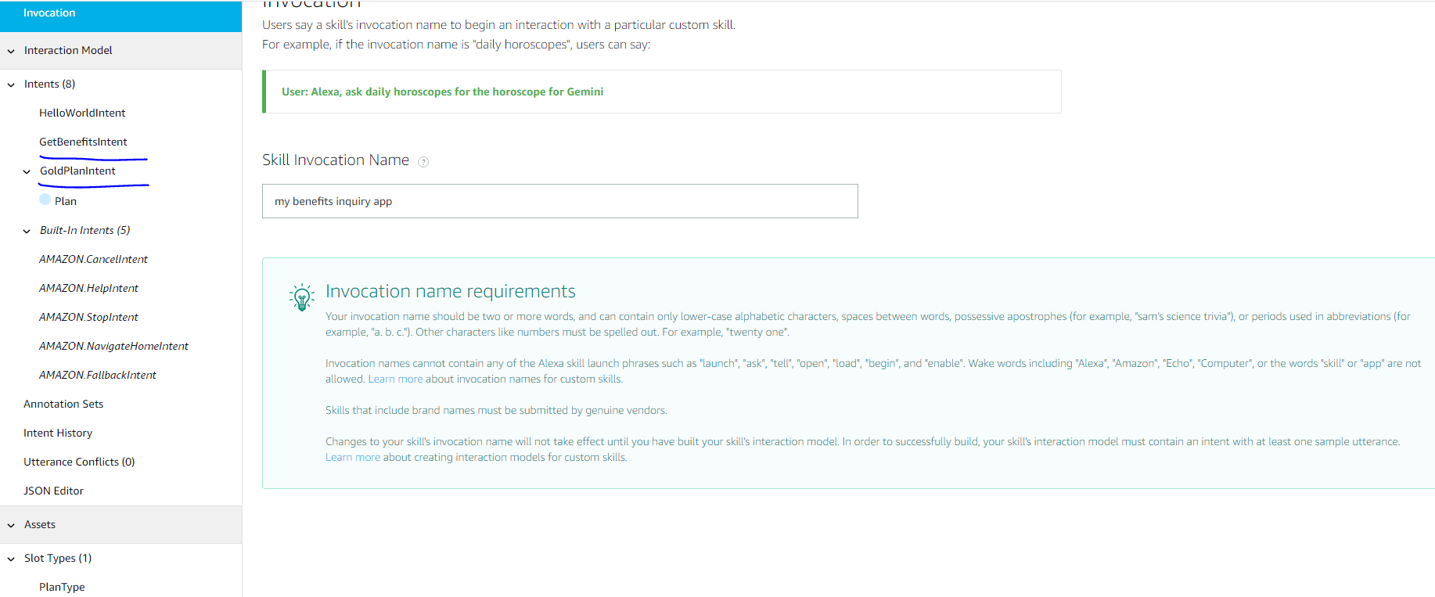

1. After the launch request it is calling the fall back intent instead of GetBenefits intent

